**DAILY ONLINE ACTIVITIES SUMMARY**

|  |  |  |  |  |
| --- | --- | --- | --- | --- |
| **Date:** | | **12-06-2020** | **Name:** | **Latika Kavoor** |
| **Sem & Sec** | | **4th Sem & A-Section** | **USN:** | **4AL18CS035** |
| **Online Test Summary** | | | | |
| **Subject** | **-** | | | |
| **Max. Marks** | **-** | | **Score** | **-** |
| **Certification Course Summary** | | | | |
| **Course** | | **INTRODUCTION TO JAVA** | | |
| **Certificate Provider** | | **GREAT LEARNING** | **Duration** | **4 hrs** |
| **Coding Challenges** | | | | |
| **Problem Statement:**Given two positive integer start and end. The task is to write a Python program to print all Prime numbers in an Interval | | | | |
| **Status: Completed** | | | | |
| **Uploaded the report in Github** | | | **Yes** | |
| **If yes Repository name** | | | <https://github.com/alvas-education-foundation/latika.kavoor/tree/master/coding_solutions> | |
| **Uploaded the report in slack** | | | **Yes** | |

Online Test Details: (Attach the snapshot and briefly write the report for the same)

NO TEST CONDUCTED

Certification Course Details: (Attach the snapshot and briefly write the report for the same)

I started with Introduction to Java course by Great Learning. I saw videos of the course. I even gave a quiz on Operating System conducted by Moodlakatte Institute of Technology.I have uploaded the certificate on my GITHUB account.

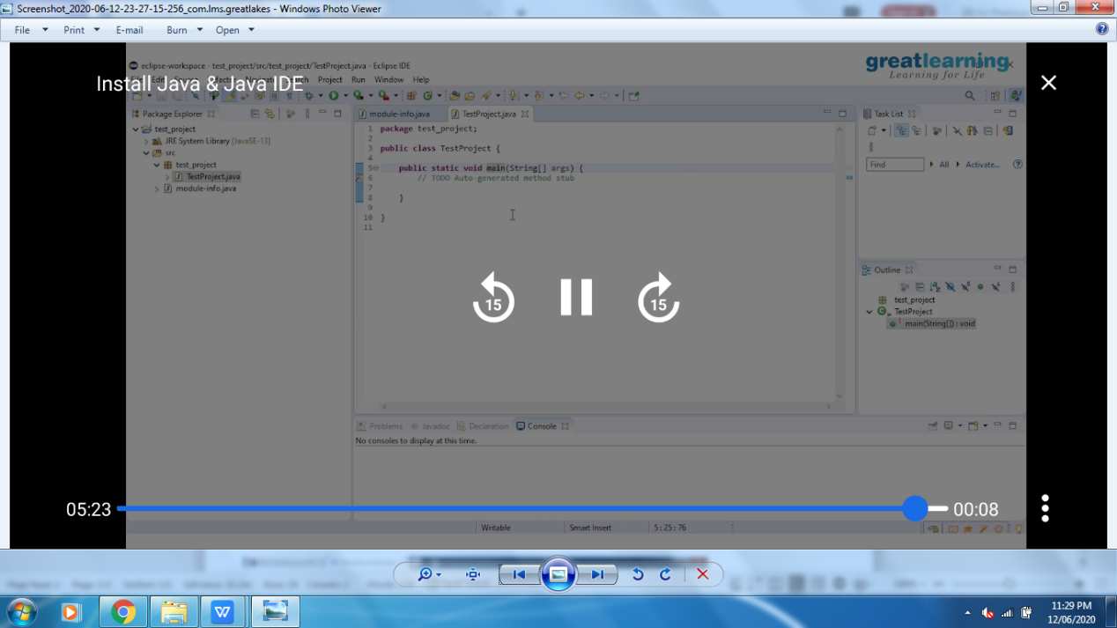

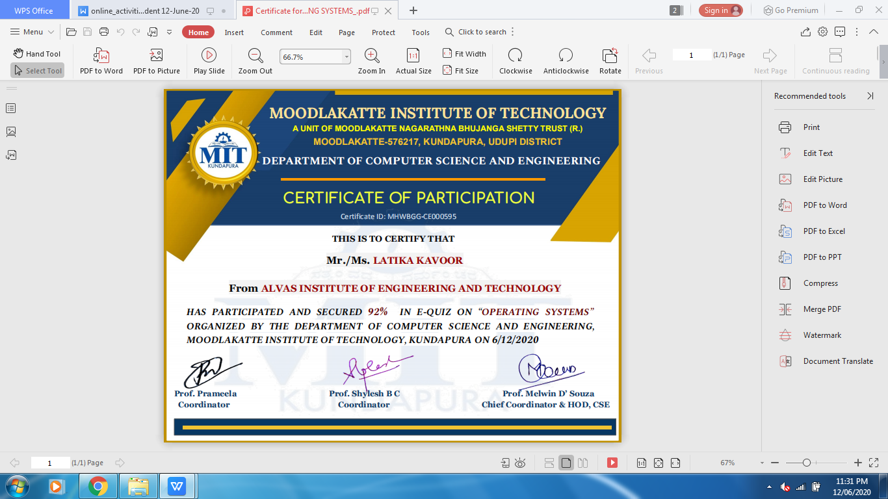

Coding Challenges Details: (Attach the snapshot and briefly write the report for the same)

Solved the problem and uploaded the same on github

